Monday 6th April

Dear Families,

On Friday 3rd April Ofqual, the government agency responsible for education qualifications, announced its systems for ensuring that Year 11 and Year 13 students receive grades for the qualifications they have been studying. Each school will be asked to indicate the correct grades for students, based on all the evidence the school has of a student’s progress and attainment to date. The estimated grade will be based on classwork and homework; results in assignments and any mock exams; any non-exam assessment or coursework you might have done; and general progress throughout the course. The government will moderate these grades so that they are fair across all schools. Further information and guidance can be found here:-

In line with Ofqual’s advice, students should not submit any further work to the school for assessment, only submit work that was issued before the closure of the school. A letter to students outlining the process and expectations can be found here:-

In the meantime, please do not request estimated grades from the school, as Ofqual guidance clearly states that we are unable to do this.

I fully understand how difficult these last few weeks have been for you all. I will write to you again when I receive further information from Ofqual. In the meantime have a safe, happy and restful Easter break.

Yours faithfully,
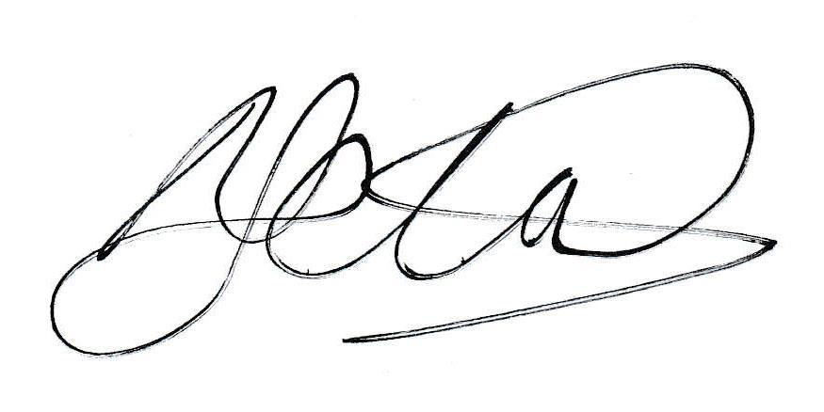
Michael Schofield
Headteacher

